|  |
| --- |
|  |
| Gee Wiz |
|  |
| GeeWizLogo.png  Version #5.0  All work Copyright © 2011 by VOODOO Games.  All rights reserved. |
| **Author** |
|  |

Jason Acosta

|  |
| --- |
| October 18th 2011 |

**Table of Contents**

[Your Table of Contents should go here. Make sure that your document’s sections are hyperlinked to their corresponding pages.]

**Version History**

Version 1.1 - Starting the project, added ideas and some gameplay

A 2.5D side scroller game.

1st Level you are shrunk down.

End of 1st Level you fall into a cauldron and transform back to your original size.

2nd Level you are in a jungle.

End of 2nd Level you finally capture Boney and regain your staff of Augmentation.

If you are green you are poisoned

If you are purple you are cursed

Lives

[This is the body of your video game design document. You should add and delete sections as they pertain to your game’s design.]

1. **Game Overview**

**Gee Wiz is a 2.5d side scroller game that uses the Udk editor and complex scripting to attract audiences of all ages. Spells, power-ups, and unique monsters; Gee Wiz is a different experience with its cartoony concept. Two intricate levels that make you feel part of the fantasy.**

**Story**

**After countless years of fighting with the mage federation, Blank has retired and settled down back at his house in the outskirts of Camelot. Still practicing magic, Blank decides to construct a weapon more powerful than any wizard. While crafting the weapon Blank starts to notice something odd about the jungle not too far from his house. It looks like Blank is back on duty.**

**Philosophy**

**This game uses fictional characters, magic, and a vast imaginary world to put the player in a fantasy land. Our goal is to design this game as something no one has played before, to throw the player into the fantasy world of Camelot and make them feel the part of the wizard. We want to use the Unreal engine to try something new, make a side scroller game out of a 3d game engine.**

**My goal design goals**

**The design goals for the game are to advance on the adventure/plat former genres. We want to give the player an excited experience, and a challenging experience.**

**Common Questions**

**What is the game?**

**This game is a 2.5D side scroller with a story about a wizard that wanted to achieve extreme power but was robbed of his dream by lesser being he never knew existed in his time.**

**Why create this game?**

**We want to create this game because we feel that adventure games and the plat former genre is slowing dying. To prevent such a fantastic genre from depleting we want to show the entertainment industry that we can expand on this genre.**

**Where does the game take place?**

**The game takes place in the outskirts of Camelot, the wizards house is the main starting point. The area is surrounded by forests, beaches, volcanoes, and mountains.**

**What do I control?**

**The player controls a wizard who use to be a master magician and part of a wizard coalition that protected the entire land of Camelot.**

**What is the main focus?**

**The focus of the game is the wizard is trying to get his staff back from the evil witch doctor Boney.**

1. **Game Play**

**Mechanics**

**This game uses a mouse aim system that can rotate about 360 degrees. The player uses this along with the given spells to defeat waves of enemies. The game uses a draining health system. In order to maintain player’s health and magic at a desired level he must collect runes. (Restores magic) Other pickup items such as: Feathers, Shards, and Elixirs help the player move quickly, build up energy for a powerful spell and stay cured from curses and poison. Players are given 3 lives to start out with. Hats give an extra life they can be found in random parts of the levels. When a player has no more lives the game is over and the player would have to start from the very beginning. Progression is simple the player works his/her way to the end of the level untouched gathering power-ups to later help him/her on more difficult challenges.**

**Status Effects**

**Throughout the game some enemies cause status impairing effects. Curse’s are skeletons that cause damage but can also cause the curse which increases the amount of magic needed to cast your spells. The player will know when they’re cursed because the character will turn a dark purple color, and be told by a brief pop up message. The Curse can be cured using an Elixir.**

**Mosquito pilots are another enemy that can cause status impairment. If a Mosquito pilot hits the character the character will become poisoned. Poison inflicts slow damage over time unless cured. Poison can be cured by collecting an Elixir.**

**Invincibility**

**Hidden in some levels players can collect Shards. Shards are broken pieces of a star. Player’s can reassemble the star to grant access to their 5th and most powerful spell Lightning. When lightning is activated players are granted a short amount of invincibility. Players are able to destroy enemies by running through them, take no damage, and have unlimited magic.**

**General Features**

**Camera**

**The camera stays stationary.**

1. **Controls**

**WASD, Spacebar, Mouse left and right clicks, and Mouse scroll wheel.**

1. **Saving and Loading**

**There is no save feature.**

1. **Interface**

**Health and Magic**

**Health is represented by the glowing green aura. This aura will change colors every time the character is hit. Green is 100%healthy getting hit will change the aura to a brighter green this tells the player they are not at 100% health but are still pretty durable. If the character is hit again after being at the bright green aura then the aura changes to yellow. Yellow is the border line 50% health indicator. Being struck after yellow the aura changes to orange, orange represents caution. At orange players are aware that their health is dropping. Being hit after the aura is at orange will cause the aura to go to dangerous red, if the player is hit at red the player will die and respawn a couple of yards back. Once the player dies they will lose one life. When the player has no more lives the game is over. A player can obtain more lives by collecting hats.**

**The blue flames coming from the dragon’s mouth on the health dial represent magic. There are 6 blue flames; certain spells cost a certain amount of flames. Some spells slowly drain the flames. If magic is used up, the meter slowly starts regenerating the flames back. There are 4 spells excluding the Shock storm spell. (see XVI. Abilities)**

**The spell being used lights up on the interface bar while the rest are grayed out. Only one spell can be used at a time.**

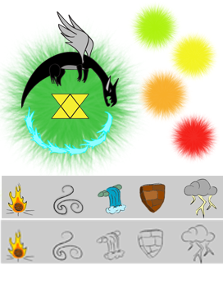

1. **Menu and Screen Descriptions**

**The title screen shows the outside of the wizard’s house. There is a watermill spinning on the river right below the house along with a waterfall flowing into the river. Players can click Start to begin the opening cinematic and start playing. There is also an “options” tiki where the player can setup preferences. Right below the Watermill is a floating barrel that reads “Exit”. Clicking exit will exit the entire game.**

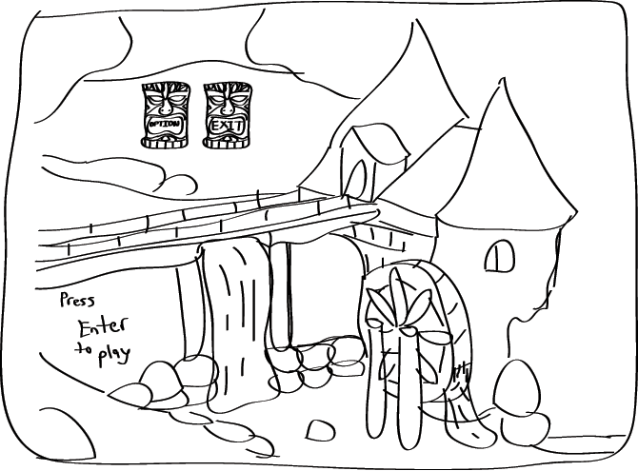

**Pause Screen**

1. **Game World**

**The current time takes place in a fantasy land sometime during the middle ages. The first level takes place inside a wizard’s house; from the beginning the game takes place in the wizard’s bedroom. In the wizard’s bedroom there are books, tables, wardrobes, pots, candles, a mirror, a ladder, and a book holder. The next area is the study room where players will find shelves, a telescope, more books and more candles. Shortly after the study room players enter the kitchen, in the kitchen you’ll see brooms, pans, barrels, various foods, a fireplace, a cooking cauldron and flour sacks.**

1. **Levels**

**The first level takes place in the wizard’s house. Boney the witch doctor breaks into the wizard’s house and steals the staff of augmentation. Boney shrinks the wizard, and now the player must proceed the rest of the house fighting off very large enemies such as the spyder, happy leech, curse, man-eating books, and the duncegoyle. At the end of the first level after fighting off the boss the wizard is knocked off the platform and into a cauldron increasing his size back to normal.**

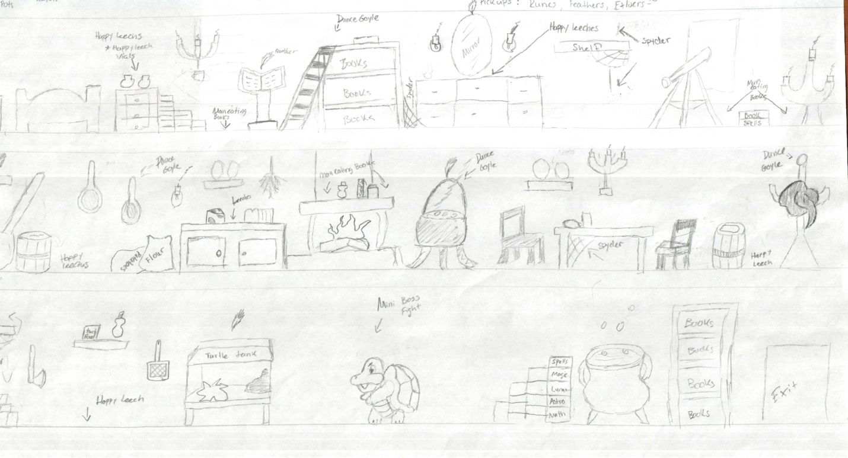

**The second level takes place in the Boom Boom jungle. The wizard races into the deadly boom boom jungle and finds that the witch doctor rigged the forest with traps. The player must avoid the dangerous traps along with the deadly forest creatures such as the poisonous Mosquito pilot, the cunning Ali-gator, vicious samurai piranha’s, Happy Leeches, and Spyder’s.**

1. **Game Progression**

**The player goes through two levels a castle and a jungle collecting power-ups and defeating enemies, at the end of each level there is a boss.**

**Tutorial**

**Before playing the tutorial screens pop-up to help players understand how to play. To get to the next page press the arrow keys, the last page has a close out button. The player must click through every page; this screen cannot be exited any other way.**

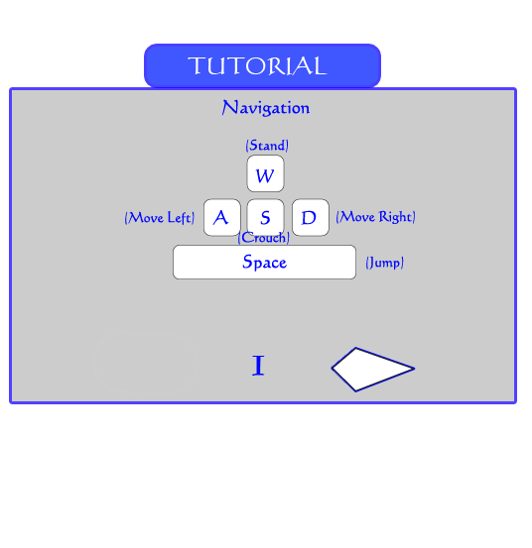

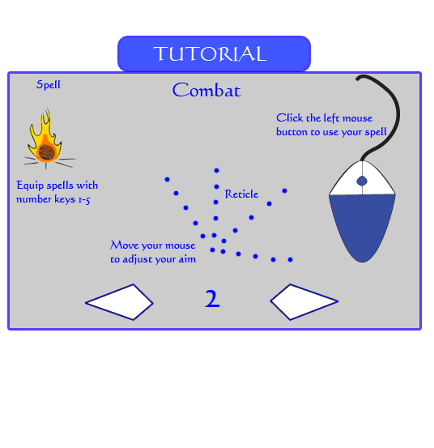

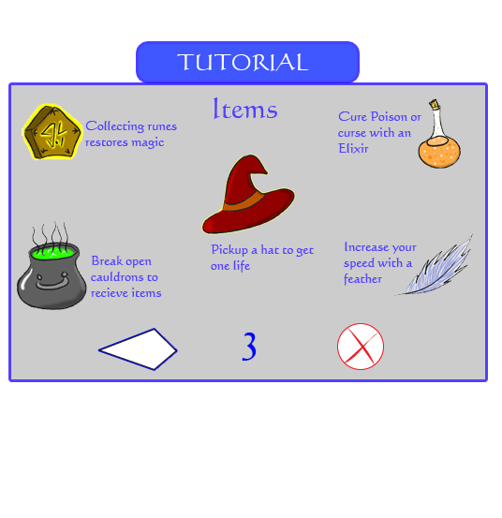

1. **Characters Overview and Concept Art**

**Wizard (Blank)**

1. **Non-player Characters**

**Boney**

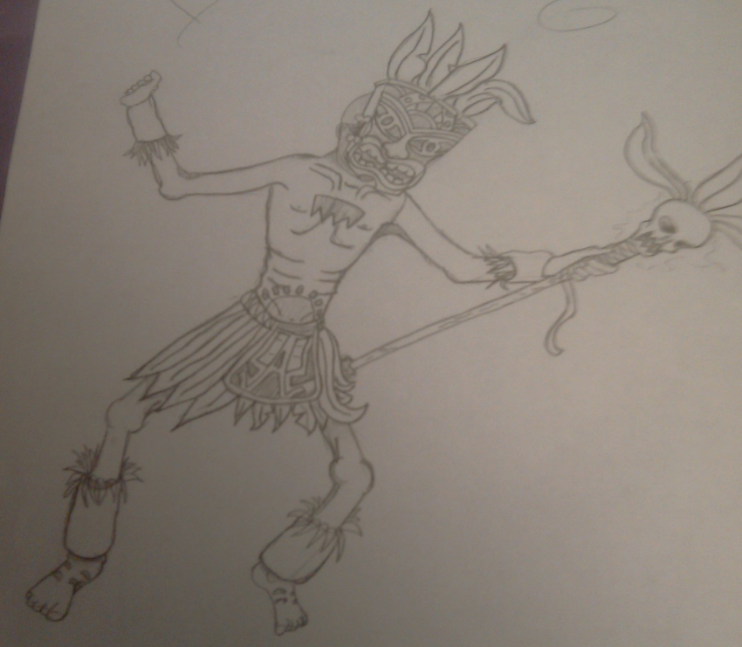

**Boney is a witch doctor that doesn’t seem to be in the right point of time. He steals the staff of Augmentation and is planning to crush the entire world once he has completed his ritual.**

1. **Enemies**

**Spyder- The spyder is rare species of spiders. They are licensed detectives and trained in advance combat. They hit more harder than the common foe.**

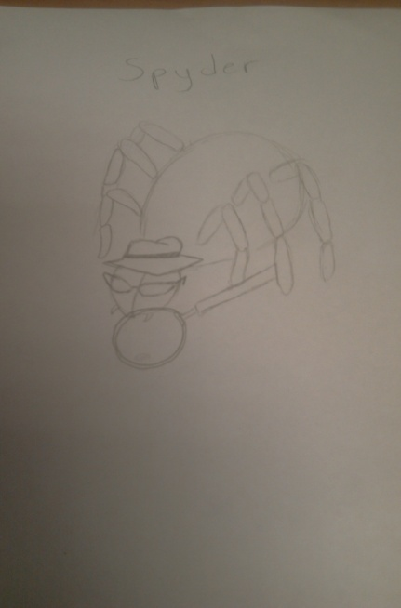

**Curse-**

**Boney’s experiments sometimes require human bodies. After decomposure the carcasses arise and start to wander. Anything they touch can cause a curse which does strange things to magic. If a Curse touches the player it will increase the cost of spells for a short amount of time.**

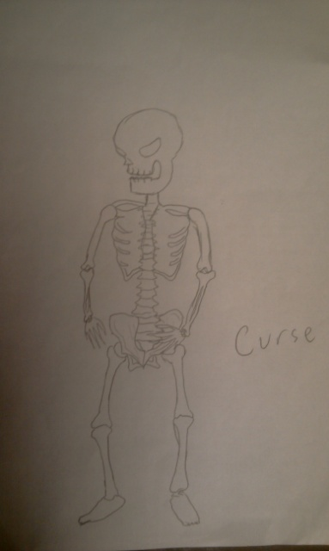

**Duncegoyle- A Duncegoyle is a gargoyle that was dropped on its head from birth. They serve the witch doctor, they aren’t quite smart. They prefer to attack from the sky.**

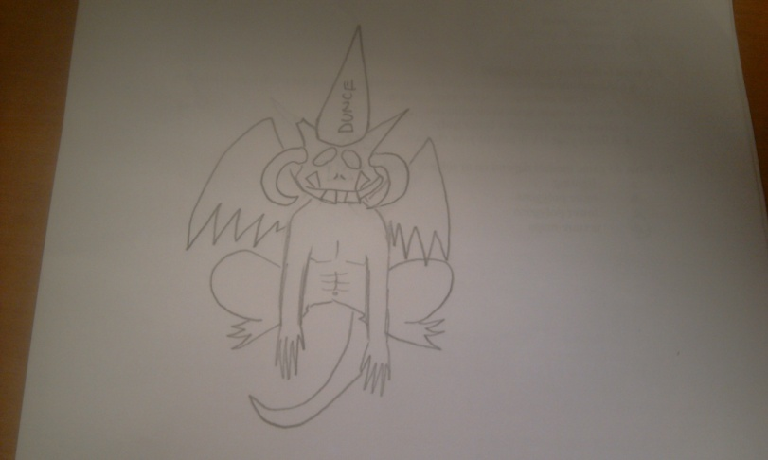

**Happy Leech- A cute leech that wonders around. They can become aggressive around magic. If a leech attaches to its target they can drain the magic out of it.**

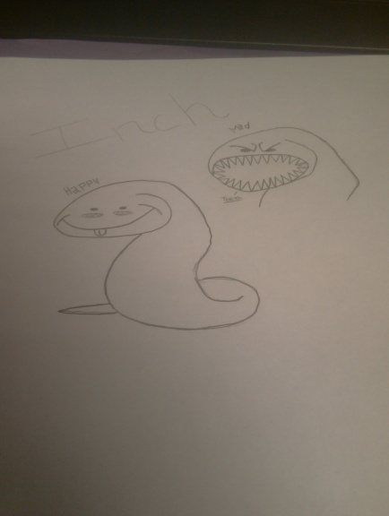

**Man-eating book- possessed books that are extremely hostile, they can attack very fast.**

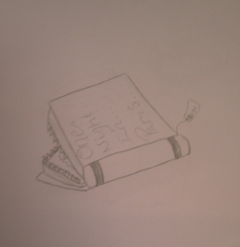

**Tortoise (boss) – What use to be Blank’s pet is now a vicious turtle. Boney has turned blank’s pet against him. The turtle can cover himself in a protective rock barrier.**

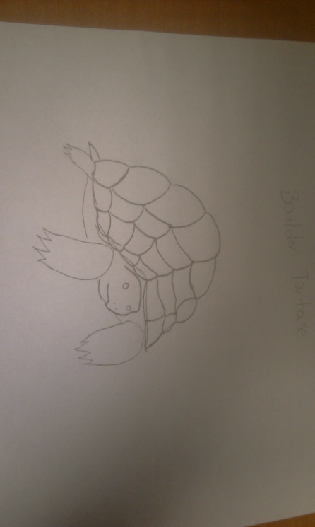

**Ali-gator- Most people would be terrified of a normal alligator but everyone is scared to step in the same ring with an Ali-gator! Ali-gators punches can send a grown man back to elementary school if not careful. These dangerous alligators have a chance to dodge attacks, and a chance to K-O victims.**

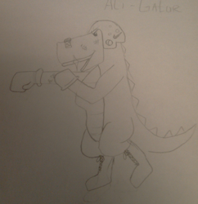

**Mosquito pilot- When the Wright brothers invented the first airplane they were unaware that a swarm of mosquitoes were seating back and watching their every move. These excellent pilots can poison anything if they make contact.**

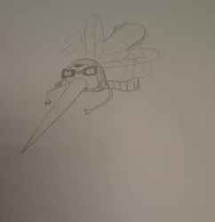

**Samurai Piranha- From the early era’s of Japan the samurai piranha dominated 89% of the bodies of water in Japan. These phenomenal swimmers can jump out of water and attack by grazing the foe with the edge of their sword.**

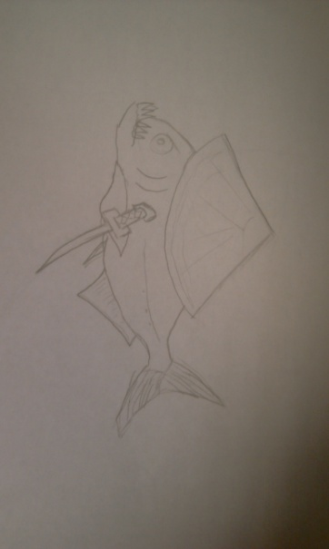

1. **Items**

**Runes – Restores magic**

**Feathers – Increases Speed for a short amount of time**

**Elixir – Cures Poison/Curse**

**Shards- Powers up Lightning Meter**

**Hats- 1 life**

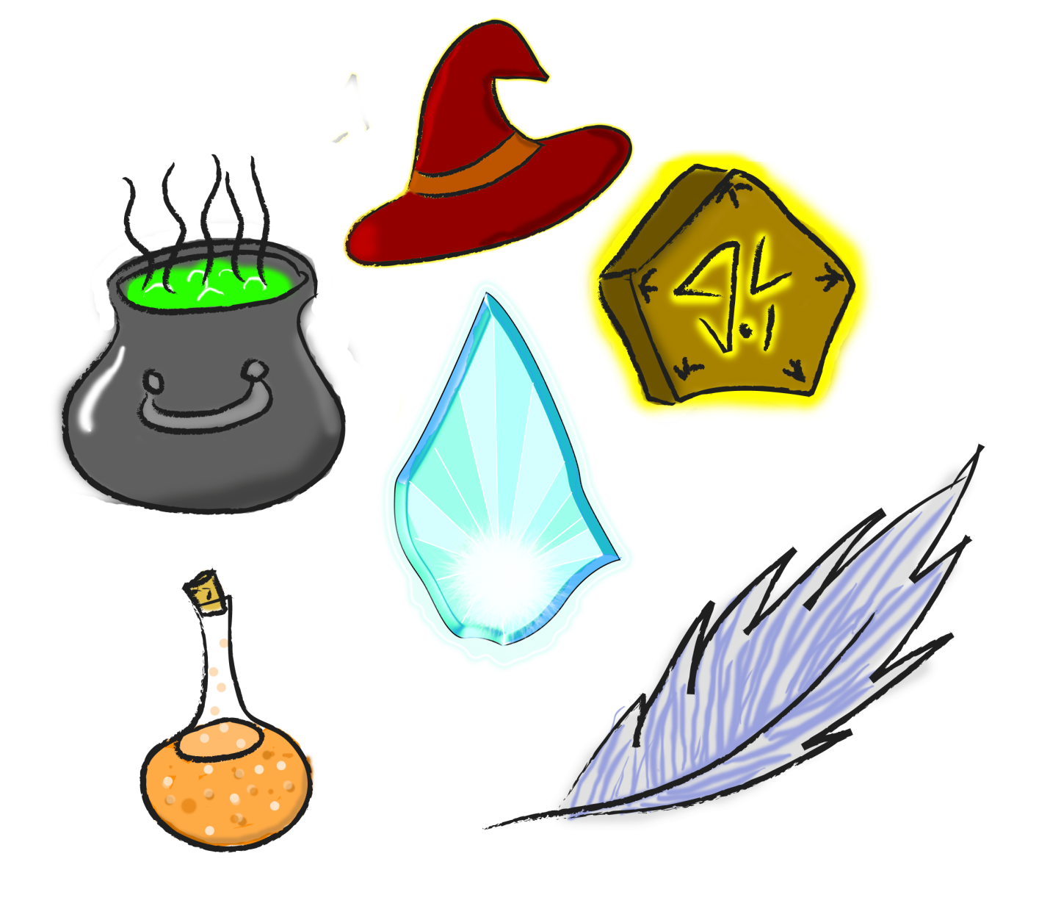

1. **Abilities**

**1Nova - Basic Damaging Attack - cost 1 bar of magic**

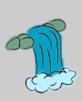**2Deluge - Casters only form of healing - cost 3 bars of magic**

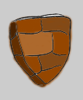**3Rock Aegis - Absorbing shield that grants temporary Immunity - Drains magic slowly**

**4Gale - Pushback enemies – cost 2 bars of magic**

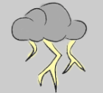**5Shockstorm - Amplified strength, Spells don’t cost any magic, and immunity**

**(Last a short amount of time)**

1. **Single-Player Game**

**Overview**

**The game experience itself starts out nice and easy enemies can hit you, enemies can hit fairly hard at a slow pace. Starting out some enemies are seen often such as happy leech, but as the player progresses they start to see newer enemies that can hit more effectively, and attack faster. Further into the game enemies start to adapt to your playability and can outwit you.**

**The key components in the singe player mode are as follows:**

1. **Kill Enemies and obtain power-ups and items.**
2. **Complete levels by defeating the bosses.**
3. **Find secret areas and collect role points to enhance your magical abilities.**

**Story**

**After fighting with the magician coalition, Blank decides to settle down back at his house in the outskirts of Camelot. Still honing his magic skills, Blank decides to construct a staff more powerful than any wizard. While constructing the weapon Blank starts to notice something odd about the jungle not too far from his house. Blank decides to go check out the forest and find an army of strange creatures.**

**Hours of Game play**

**Single player mode at the moment only has two levels which are about 15 to 30 minutes long. In total there is about 1 hour of gameplay.**

**Victory Conditions**

**To win in single player mode, the player has to defeat the last boss in the level and progress to the next level. The end game victory condition is to defeat Boney and take your staff back.**

**Game Over**

**If the player has lost all of their lives this game over screen will pop up the player can then decide to continue or to not continue. If the player selects yes, they will placed at the beginning of the first level. If the player selects no, they will be sent to the main menu screen.**

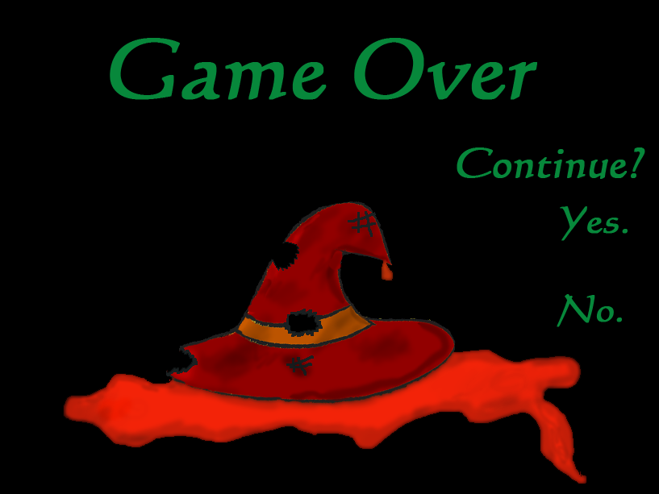

1. **Script**
2. **Bonuses**

**During the Game, players with stumble upon a flashing green arrow that says “bonus” pointing down, this tells the player that a bonus round is down below. When the player dives down they will land in a room with just a giant cauldron. While in a bonus room players are timed and are granted unlimited magic as long as they are down in the bonus room, players use this unlimited magic to break the giant cauldron. The cauldron has a lot of health so the player must destroy it quickly. Destroying the giant cauldron releases four random items. The items in the cauldron are Runes, Elixirs, Feathers, and Shards.**

1. **Sound Bible**

**-----**

1. **Future Features**

**More Levels:**

**Volcano**

**Temple**

**Camelot**

**More Spells:**

**Ivy**

**Lightwave**

**More Monsters:**

**Cheap bird**

**Courageous Crab**

**Goblynns**

**Samuel L Saxon**

**T.R.U.S.T**

**Harvester**

**Talent Tree Machanics**

